**Jenkins High Availability (HA) – Explanation with Failover**

In our Jenkins High Availability architecture –

* HAProxy – It will be at frontend. We will be using HAProxy IP to access the Jenkins dashboard from browser.
* Jenkins – Two instance of Jenkins will be configured as backend. One of them will be in Active mode & other one will be in passive mode. Basically, it will be Active-Passive model.

We will have below –

Jenkins 1 – Active Jenkins instance, HAProxy will always send traffic to this instance as long as it is up & running.

Jenkins 2 – Passive Jenkins instance, HAProxy will send traffic to this instance only when Jenkins 1 is down.

Below is a simple diagram which explains our Jenkins High Availability or Jenkins HA architecture.

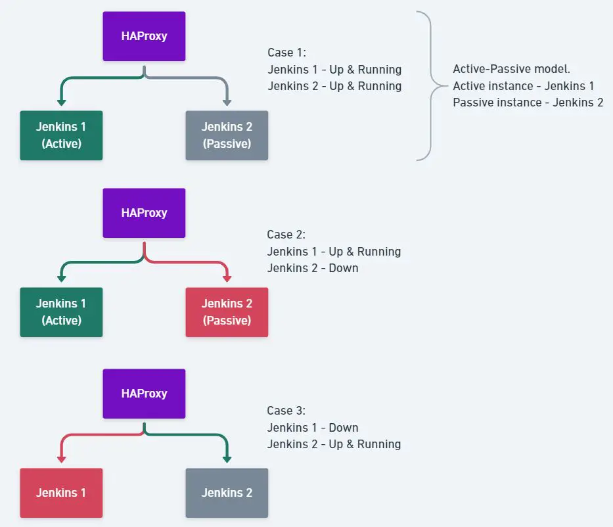

**Jenkins High Availability (HA) – implementation guide**

Below is the step-by-step guide –

**Step 1: Install two instances of Jenkins on two separate machines**

In this tutorial we are using two RHEL machines where we will install Jenkins. You need to execute below commands one by one.

sudo wget -O /etc/yum.repos.d/jenkins.repo

<https://pkg.jenkins.io/redhat-stable/jenkins.repo>

sudo rpm --import https://pkg.jenkins.io/redhat-stable/jenkins.io.key

sudo yum upgrade

sudo yum install java-11-openjdk

sudo yum install jenkins

sudo systemctl daemon-reload

sudo systemctl start jenkins

sudo systemctl status jenkins

**If you have Linux machine of other flavor like ubuntu, centos etc. then please head over to below article for Jenkins installation. Once you complete the Jenkins installation come back here.**

[Jenkins Installation on various OS – a simple practical guide](https://cscontents.com/jenkins-installation-on-various-os/)

Once you see both the Jenkins instance up & running, open your browser and check whether the URL of both the Jenkins are accessible or not. Jenkins URL is in below format.

http://<IP_address_of_your_machine>:8080

***Note: Port 8080 should be allowed in your machine network. Inbound rule should be added with port 8080.***

Now, follow the given instruction in Jenkins UI and complete Jenkins setup.

**Step 2: Mount the NAS drive in both Jenkins machine**

In step 1, we have installed two instances of Jenkins on two separate machines. Now, we need to mount a NAS drive at /var/lib/jenkins/job directory on both the machine. This is because all the jenkins job related configuration & build information are stored in the /var/lib/jenkins/job directory.

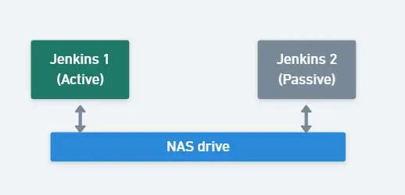

**Step 3: Install HAProxy**

In this step we will install HAProxy on a different machine. In our case we will be using one Ubuntu machine where HAProxy will be installed.

Execute the below commands.

sudo apt update

sudo apt install haproxy

**Step 4: Configure HAProxy to point to the Jenkins instances**

To configure HAProxy we need to edit the /etc/haproxy/haproxy.cfg file.

Open the /etc/haproxy/haproxy.cfg file by running below command.

sudo vi /etc/haproxy/haproxy.cfg

Once you open the haproxy.cfg file, delete or remove all the content from this file.

Now copy & paste the below content in the haproxy.cfg file and edit the IP address of jenkins1 & jenkins 2 (enter your IPs).

defaults

mode http

log global

option httplog

option dontlognull

option http-server-close

option forwardfor except 127.0.0.0/8

option redispatch

retries 3

timeout http-request 10s

timeout queue 1m

timeout connect 10s

timeout client 1m

timeout server 1m

timeout http-keep-alive 10s

timeout check 10s

maxconn 3000

#---------------------------------------------------------------------

# main frontend which proxys to the backends

#---------------------------------------------------------------------

frontend main

bind *:80

default_backend jenkins_servers

reqadd X-Forwarded-Proto:\ http

backend jenkins_servers

server jenkins1 45.228.89.101:8080 check

server jenkins2 80.201.179.58:8080 check backup

***Note: Port 80 should be allowed in your machine network. Inbound rule should be added with port 80. Your HAProxy machine should be able to communicate with both Jenkins instance over port 8080. Also, both Jenkins instance should allow inbound communication from the HAProxy machine.***

**Step 5: Start the HAProxy**

Now, start the HAProxy by running below command.

systemctl start haproxy

Check the status of HAProxy,

systemctl status haproxy

**Step 6: Add a Cron Job in Jenkins-2 to Reload**

Though we are using one NAS drive to sync the job related data between the two Jenkins instance. But if we create/edit any job in the dashboard of Jenkins-1, that change or edit would not be automatically reflected in the dashboard of Jenkins-2. To reflect those changes, we need to reload the Jenkins 2.

There are few ways through which we can reload any Jenkins instance –

1. From browser if we hit this URL → http://<Jenkins_machine_IP>:8080/reload, it would be reloaded.
2. From the Jenkins machine CLI, if we run this command, curl -u user:api_token http://<Jenkins_machine_IP>:8080/reload, it will be reloaded.
3. If we restart the Jenkins instance then also it gets reloaded.

We will follow the second approach (point number 2) to reload Jenkins-2, and we need to reload it every time when we do any change in Jenkins-1.

To avoid the manual reloading of Jenkins-2, we would create one cron job in Jenkins-2 which will run a shell script every 1 min to reload it. Now, to reload Jenkins using the above-mentioned curl command we need a user & API token.

Below are the steps which you can follow –

**Step 6.1: Create an API Token**

You need to create an **API token** for the Jenkins user which will be used for reloading the Jenkins instance using curl command.

Once you log into Jenkins dashboard, in the top right corner you would see the username and with that you would see a dropdown.

* Click on that dropdown.
* In the dropdown, you would see ‘Configure’ option, click on that ‘Configure’ option

Once you open the above-mentioned ‘Configure’ page, you need to create an API Token there. Copy & paste the API token in any notepad.

**Step 6.2: Create a Shell Script**

Now we will create a shell script. In our case we will create the shell script in /root directory. You may create in any other place also. Execute the below commands.

vi jenkins_reload.sh

Copy & paste the below content (replace the user & API token with your details).

**#!/bin/bash**

curl -X POST http://localhost:8080/reload -u admin:11nh69f9065929u3a83a65abe3ba78dfbg

Save the file.

**Step 6.3: Create a Cron Job**

In this step we will create a cron job to run the above shell script every 1 min. Execute the below commands.

sudo vi /etc/cron.d/jenkins_reload

Copy & Paste the below content.

*/1 * * * * root /bin/bash /root/jenkins_reload.sh

Save the file.

**Step 7: Access the HAProxy URL from browser**

Finally, we can access our highly available Jenkins instances through the HAProxy IP address or HAProxy URL (if DNS is configured). Basically, you need to access the below URL from browser.

[http://haproxy_ip_address:80](http://haproxy_ip_address/)

*Note: Jenkins instances should be up & running. If any one of them is down then also we will be use Jenkins since we have two Jenkins instance.*